**Koyo Software Solutions** May 06, 2021

1305, 6B, Whispering Palms, Akurli Road, Kandivali East, Mumbai, Maharashtra, India 400101

+91 98679 10690

[KoyoSoftwareSolutions@gmail.com](mailto:KoyoSoftwareSolutions@gmail.com)

<https://tts-website-79023.web.app>

Gau Nandi Seva – Website Structure & Write-up

Attention: Akash Maurya for Web development

1. We need 2 pop-ups.

Popup 1

“We use cookies to enhance your experience. Click  to grant your consent.”

1. The button above must be in saffron and red instead of pink and violent. Upon hover the button should change to green 
2. Location: At the top of the Hero, just below the Nav Bar.

Popup 2

Popup name: Get Involved

Popup Text: We conserve Indic breeds. We nurse the sick & injured. We build compassionate communities. Your Heart is our strongest asset. Click here. Discover your Soul Song.

Appearance time: 15 seconds after the site has been fully loaded OR when clicked on top bar OR at footnote.

Animation method: Fade in and fade out

Duration: Desktop: floating - 5 seconds and then auto-disappear unless user starts to type; floating - 3 seconds on phones

Max size: Desktop: 10% of the screen; 25% on phones

Placement: see illustration below

Desktop

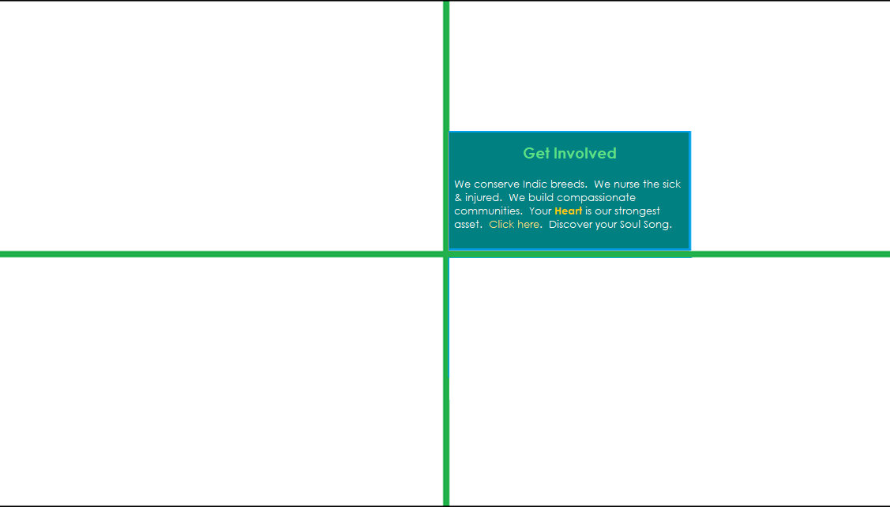

Phone

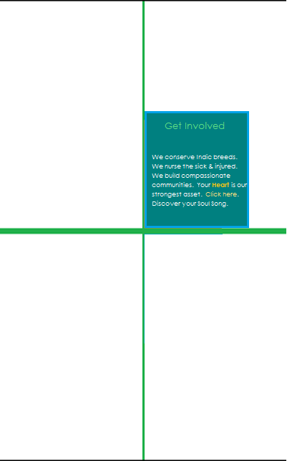

1. Non-floating Top Bar

Phone WhatsApp Telegram Email Festive Sale  AR 

EN 

ES 

FR

1. Floating Navigation Bar

Firm Name: “Gau Nandi Seva Compassion in Practice” Home: Home symbol button Royalty Free Vector Image - VectorStock “About” “CSR” “Join” “Gau Sevak” “Locate”

1. Floating Right Sidebar

SOS

- Name

- Phone Number

- Upload SOS Location

- Message Box

- Upload Photo

Give

Buy

1. Hero (1 text, 1 video and 1 photo)

Heading: “Gau Nandi Seva Guided by Purpose Powered by Hearts of Volunteers” Carousal size ratio - 2700 x 1500 pixel (2700 wide)

Boxes: Events, Gallery, Videos

Text: “Advocate compassion. Involve Communities. Conserve Indic breeds. Rescue from slaughter. Bring abandoned back to home.”

1. Heading: “Our Story”

Text: “We are located in the picturesque Chemmanda village, 20 km from the little explored Valapad beach that guarantees endless sand walks amidst gently swaying coconut trees and a quiet environment to connect with your inner self.

The Gaushala shares home with the ancient Subramanya and Narasimha Swamy temples that include a large pond within the precincts.

The Gaushala land was received in donation for the purpose of conserving indigenous breeds and providing a shelter to homeless cattle. If your luck blesses you during your volunteering stay, then you may spot occasional visitors – elephants!

We house 25 bulls and 20 cows. Out of these 18 (mostly crossbreed bulls) were injured, rescued, orphaned or abandoned before they found their home here. The indigenous breeds are housed separately to support conservation. Some of these were driven to near extinction due to secular state interventions beginning in early 1960s. These interventions, with their single-minded focus on [milk yield/cow], forced castrations of indigenous bulls and heavily subsidized ownership of high-yielding crossbreeds.

The practise of maintaining gene pool diversity is ages old. With increasing awareness of anti-biotic resistance-inducing effects of standard dairy milk, this practise is regaining fledging support. Indigenous breeds are well-suited to the hot humid climate, yield barely 3 litres but do not require feed supplements. Their milk tends to be of the A2 type, higher in easily digestible polyunsaturated fats and is famed for its [anti-bacterial property](http://www.bioinformation.net/006/97320630006275.pdf) which can exceed that of the antibiotic ampicillin! While the Gaushala does not engage in commercial dairy, it actively advocates and presents harmonious practises as a solution to modern needs.

Currently we have 9 cattle of the Vilwadri breed, 6 each of the Vechur and Kasargod breeds and 5 of the Cheruvally breed. ”

The Gaushala is conscious of its responsibility of developing compassionate communities. Within our meagre means, we are attempting to raise awareness on the issue of abandonment or sale-to-slaughterhouse of old cattle. We rescue them whenever we can and bring them home. Check out the adoption section to find out how you can make a difference.

We are happy to host short visits, particularly from large city residents. Please book an appointment here or contact to find out more. Alternatively, we could help you plan a long, more purposeful stay if you wish to volunteer.”

1. Gau Nandi Seva on the Social Media
2. Virtual Adoption Banner

We brought Guruprasad 1 ½ months ago after met with a road accident. He is undergoing a slow recovery from painful rib and limb fractures.

Sprouted pulses and green fodder will help him recover faster. He has a weakness for juicy watermelons and overripe bananas!

He needs regular wound dressing and food. Adopt him for a month for ₹1500. We will email you updates about him till he completes recovery.



It will be done like here: <https://tts-website-79023.web.app>



1. Small Print

We ensure your messages are well-received. Small prints ease their way on to people’s desk tops and thereby are a great tool for subliminal marketing.

Arrange all the products below in the format given below:

Badge Brochure Certificate Envelope Flyer Invoice Menu

Name Card Greeting Card Postcard Report

Use formatting from <https://desifirangifoods.web.app> hero. But with the following difference:

1. No background
2. The collection to be center-justified.

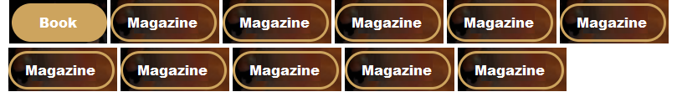

When clicked here, it should go to the following format which is on <https://desifirangifoods.web.app>

Instead of having Dine-in, Take-away, etc you will have Badge 

Brochure 

Certificate 

Envelope etc.

Heading: Event or Name Badge

Color-coded event badges are a great way to keep intra-personnel identification and communication clear. They also make help more accessible to attendees.

Database:

Size: **3x4**”, 3x5”, 3.3x5.5”, 3.8x5”, 4x5”, 4x6”, 5.5x8.0**”**, custom

Paper: **14pt gloss laminate**, 18pt gloss laminate, 14pt velvet laminate, 18pt velvet laminate

Hole Drill: **1**, 2

Corner: Rounded, **Square**

Color: **Single color**, Multicolor, Full color

Design: **User provided**, Template, Custom-designed

Qty: **10**, 25, 50, 200, custom

Price: 80 Dhm

The image on right will be rectangular, not circular. It should be possible to click on the image and magnify it to fit to the width or height, whichever is smaller.

You would see thumbnails at the bottom – anything between one to 5 thumbnails per set which should all fit in max one row for desktops. For phones, they should be in ribbon scroll format just below the image.

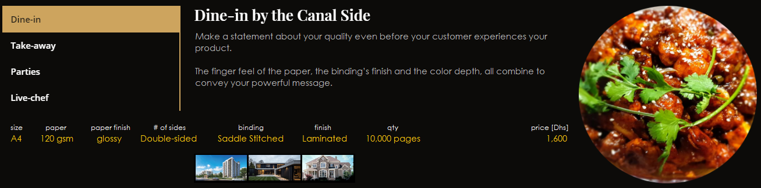

**Recently-viewed products will be mentioned at the bottom. And, there must be a like icon.**

Heading: Brochures, Catalogues & Magazines

Text: Make a statement about your quality even before your customer experiences your product.

The finger feel of the paper, the binding’s finish and the color depth, all combine to convey your powerful message.

Database:

Size: A4, A5, A6

Paper: 130gsm, 150 gsm, 180 gsm, 210 gsm

Paper finish: matt, glossy, satin, dull, coated

# of sides: single, double

Binding: comb, perfect, saddle, sewn, stitch, spiral

Finish: spot UV, laminated

Qty: 5,000, **10,000**, 20,000, 50,000, custom

Price: 1,600 Dhm

Heading: Certificates

Text: Certificate is a reward. The quality should convey well-earned pride.

Choose from the options below or give us a call and we will help you build lasting pride on the top of your efforts.

Database:

Size: A4, **A5**, A6

Paper: 14pt Matte Cover, 100lb Matte White, 100lb Silk Cover, **160gsm Cream Ivory**, 220gsm white ivory

Color: **4/0 - Full Color**, 1/0 Spot Pantone Colors

Finish: Seal hot stamping, **Emboss on seal**, Hot stamping wording

Design: **User provided**, Template, Custom-designed

Qty: **50**, 100, 200, 500, custom

Price: 240 Dhm

Heading: Envelope

Text: We print envelopes in all standard sizes, paper types, colors, and description. We prefer vector art PDF files with halftone images at 300dpi.

The finger feel of the paper, the binding’s finish and the color depth, all combine to convey your powerful message.

Database:

Size: Business 6-1/4, Business 7, **Business 8**, Business 8-5/8, Business 10, Business 11, Business 14, Booklet 6-1/2, Booklet 6-5/8, Booklet 9, Booklet 9-1/2, Booklet 10, Catalog 6x9, Catalog 9x12, Catalog 10x13

Paper: Wove, **White Wove**, Kraft, Recycled, Specialty, Tear-resistant

Window Cut: **Yes**, No

Watermark: **Yes**, No

Thermography: **Yes**, No

Emboss: Yes, **No**

Qty: **100**, 200, 500, 1000, custom

Price: 220 Dhm

Heading: Flyers & Leaflets

Text: Flyers are a cheap way to get your message across to a large number of clients.

They are particularly useful for raising the awareness about your products, services or specialty in the market.

Database:

Size: Business A4, A5, A6, **DL**, Custom

Paper: **80** gsm, 100 gsm, 130gsm, 140 gsm, custom

Qty: **100**, 200, 500, 1000, custom

Price: 90 Dhm

Heading: Invoice

Text: Invoices and Bills must be cheap, professional-looking and easy to work with.

Talk to us about customizing the bills to suit your needs.

Database:

Size: 4.2x5.4”, **5.5x8.0”**, custom

Paper: **Self carbon**, NCR

Paper Type: **60gsm**, 80gsm, 100gsm, 130gsm

Color: **Single color**, Multicolor, Full color

Copies: **Duplicate**, Triplicate

Booklet: **200pg**, 500pg

Design: **User provided**, Template, Custom-designed

Qty: 2, 5, **10**, 20, 50 booklets, custom

Price: 180 Dhm

Heading: Menu

Text: Classy menus communicate a strong message of quality. Research has shown that they also subliminally positively influence appetite.

Consider a 2-sided L-stand of your most in demand items. Add pictures. They save your clients from having to think through your words!

Database:

Size: A4, **A5**, A6

Paper: 14pt Matte Cover, 100lb Matte White, 100lb Silk Cover, **160gsm Cream Ivory**, 220gsm white ivory

Color: **4/0 - Full Color**, 1/0 Spot Pantone Colors

Sides: One, **Two**, Booklet

Format: **Standard**, Tent, Tri-folded, Folded takeout, Gateway takeout

Binding: **none**, comb, perfect, saddle, sewn, stitch, spiral

Effects: Seal hot stamping, **Emboss on seal**, Hot stamping wording

Finish: Acrylic L-stand, Leather-binding

Design: **User provided**, Template, Custom-designed

Qty: 10, **20**, 50, 100, 200, custom

Price: 40 Dhm

Heading: Name Card aka Visiting Card or Business Card

Text: Print your visiting cards with us and leave a memorable impression.

In case you need digital visiting cards to exchange over social media or include in your email signature then please see our branding services.

Database:

Size: 2.0x3.5”, 1.5x3.5”, 3.35x2.17”, 2.5x2.5”, 3.0x3.0”, cutom

Paper: 14pt Matte Cover, 100lb Matte White, 100lb Silk Cover, **160gsm Cream Ivory**, 220gsm white ivory

Sides: One, **Two**

Color: **4/0 - Full Color**, 1/0 Spot Pantone Colors

Corner: **Square**, round

Effects: Aqueous Coat, **Emboss**, Spot UV, Full UV Coat

Design: **User provided**, Template, Custom-designed

Qty: 200, 500, **1,000**, 5,000, custom

Price: 130 Dhm

Heading: Greeting Card

Text: Greeting cards are a great way to convey your warmth to people you know on occasions on special occasions or life events such as promotion, successful discharge from a hospital or a simple note of thanks.

Call or WhatsApp to discuss your turnaround time needs so you do not miss the special date.

Database:

Size: 8x6” (folds to 4x6”), 10x7” (folds to 5x7”), 2.0x3.5”, 1.5x3.5”, 3.35x2.17”, 2.5x2.5”, 3.0x3.0”, custom

Paper: 100lb Gloss, 14pt Gloss, 14pt Cover, 17.5 eggshell Ultra White, 14pt Soft Touch Lux

Color: **4/0 - Full Color**, 1/0 Spot Pantone Colors

Corner: **Square**, round

Effects: Aqueous Coat, Foil Stamp, **Emboss**, Spot UV, Full UV Coat, Velvet, Soft Touch

Design: **User provided**, Template, Custom-designed

Qty: 50, 100, **500**, 1,000, custom

Price: 110 Dhm

Heading: Postcard

Text: Postcards help you communicate special occasion messages with a personal touch.

They are cheaper than greeting cards, useful for communicating small, personalized messages and can be viewed without opening the envelop.

Database:

Size: **3x4”**, 4x6”, 5x7”, 5.5x8.5”, 6x9”, 6x11”, custom

Paper: 100lb Gloss, 14pt Gloss, 14pt Cover, 17.5 eggshell Ultra White, 14pt Soft Touch Lux

Color: **4/0 - Full Color**, 1/0 Spot Pantone Colors

Corner: **Square**, round

Effects: Aqueous Coat, Foil Stamp, **Emboss**, Spot UV, Full UV Coat, Velvet, Soft Touch

Design: **User provided**, Template, Custom-designed

Qty: 50, 100, **500**, 1,000, custom

Price: 70 Dhm

Heading: Annual Report

Text: You want to create a compelling handout to communicate your message to the world. We help you put your best foot forward.

Database:

Size: **A4**, B5, custom

Paper: 100gsm, **130gsm**, 150gsm

Paper type: Coated, Uncoated, **Recycled**

Color: **4/0 - Full Color**, 1/0 Spot Pantone Colors

Effects: Aqueous Coat, Foil Stamp, **Emboss**, Spot UV, Full UV Coat, Velvet, Soft Touch, Die-cut

Design: **User provided**, Template, Custom-designed

Binding: comb, **perfect**, saddle, sewn, stitch, spiral

Qty: 1,000 pages, 3,000 pages, **5,000 pages**, 10,000 pages, custom

Price: 420 Dhm

1. Large Print

Signages are ubiquitous as you step outside of your house. They help us find directions, look up things of interest, or beautify our homes e.g. wall papers or glass decors.

We help you manage the cost of large prints by working with you to pick the right solution amongst the many possibilities we can execute to match your wants. Talk to us for a free consultation and browse our offerings below.

Format will be same as that for “Small Print”. Items are listed below:

3D Acrylic Signage, 3D LED Signage, 3D Aluminum Signage, Board: foam, Large Poster, Wallpaper, Wrapper: Food Truck, Wrapper: Vehicle Mockup Cheque, Rollup banner, Window Decals

Heading: Foam Board

Foam boards are light-weight inexpensive materials used in interiors for decorating walls, promotional or expo displays, window graphics, or shop signages.

Ask for UV treatment if you want them to last long – UV-assisted drying makes sure the print retains its vividity for many years despite exposure to sunlight.

Database:

Size: **12x24**”, 18x18”, 18x24”, 24x24”, 24x36”, 36x36”, 36x48”, 48x48”, 48x72”, 48x96”, 72x72”, 72x96”, custom

Paper: 3/16” white foam board, **3/16” black foam board**, 1/4” white foam board, 1/4” black foam board, 3/8” white foam board, 3/8” black foam board, 1/2” white foam board, 1/2” black foam board

Hole Drill: **1**, 2

Sides: **one**, two

Corner: Rounded, **Square**

Color: **one-sided full color**, two-sided full color

UV treatment: Yes, **No**

Design: **User provided**, Template, Custom-designed

Qty: 1, 5, 10, **25**, 50, 100, custom

Price: 200 Dhm

Heading: Large Poster

Size creates its own attention. Large posters can be used to draw attention outdoors, under table glass or they can adorn an interior wall.

Art prints, travel posters, architect plans, bedroom décor, social campaigns, bakery wall adornments, and more. Ask us how we can help.

Database:

Size: 11-3/4x16-1/2”, **18x24”**, 24x36”, 27x39”, custom

Paper: 100lb silk, 100lb matte, **100lb gloss**

Print Method: Lithographic, Digital, Screen, Offset

Sticker type: **semi-permanent**, temporary (allows adjustment)

Finishing: high gloss lamination

Color: one-sided full color, two-sided full color

UV treatment: **Yes**, No

Design: **User provided**, Template, Custom-designed

Qty: 1, 5, 10, **15**, 25, 50, custom

Price: 400 Dhm

Heading: 3D Acrylic Signage

3D signs, graphics cutouts and typography create professional placements that stand out both indoors and outdoors.

Window decals are for one-time use. They are also called vinyl window stickers or window graphics.

Database:

Size: 12x12”, 12x18”, **12x24**”, 18x18”, 18x24”, 18x30”, 24x24”, 24x30”, 24x42”, 24x48”, 30x48”, 36x48”, 42x48”, custom

Paper: **2 mil matte vinyl**, 4 mil matte vinyl, 6 mil matte vinyl

Sides: **one**, two

Sticker type: **semi-permanent**, temporary (allows adjustment)

Transparency: Opaque, **Clear**, Perforated

Cut: Halo, **Contour**

Color: one-sided full color, **two-sided full color**

UV treatment: **Yes**, No

Design: **User provided**, Template, Custom-designed

Qty: 1, 5, 10, **15**, 25, 50, custom

Price: 300 Dhm

Heading: Window Decals

Window Decals are a combination of typography (letter art) and graphics that are pasted on glass windows or doors for client attraction.

Window decals are for one-time use. They are also called vinyl window stickers or window graphics.

Database:

Size: 12x12”, 12x18”, **12x24**”, 18x18”, 18x24”, 18x30”, 24x24”, 24x30”, 24x42”, 24x48”, 30x48”, 36x48”, 42x48”, custom

Paper: **2 mil matte vinyl**, 4 mil matte vinyl, 6 mil matte vinyl

Sides: **one**, two

Sticker type: **semi-permanent**, temporary (allows adjustment)

Transparency: Opaque, **Clear**, Perforated

Cut: Halo, **Contour**

Color: one-sided full color, **two-sided full color**

UV treatment: **Yes**, No

Design: **User provided**, Template, Custom-designed

Qty: 1, 5, 10, **15**, 25, 50, custom

Price: 300 Dhm

1. “Delivery”: Link to this is via the shipping icon (see point 2 above). This will be from <https://bootstrapmade.com/demo/Delicious> - same as the changes you have made to the photo shown below (5 or 6 cards in a row, removal of 01, 02, etc.).

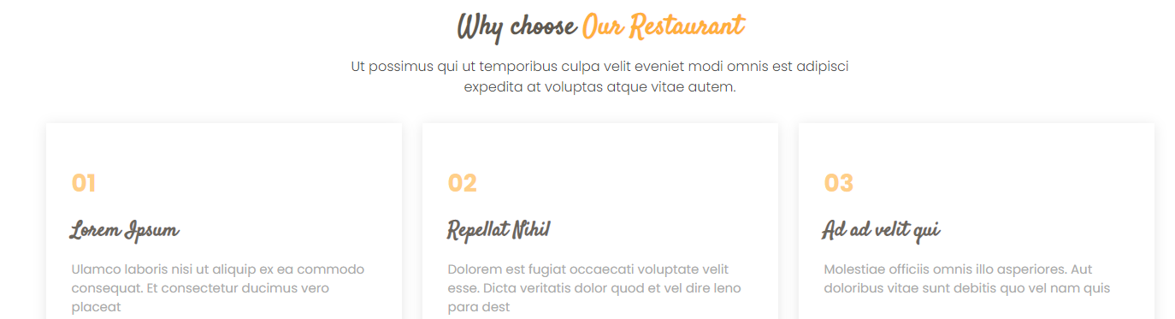

Text to be put is given below. For URL, just give URL of the respective companies. E.g. for Frichti it is [https://www.frichti.co](https://www.frichti.co/landing?slug=) etc.

~~Why Choose Our Restaurant~~ “Doorstep Delivery”

“You may be far. Breakfast, Lunch or Dinner, we are yet close to you.”

“Call, Botim or WhatsApp us or simply order below.”

“Timing for orders placed directly with us Sun-Thu: 0930-1630 

Thu: 0930-2230 

Fri: 1030-2330 

Sat: 1630-2030”

|  |  |  |  |
| --- | --- | --- | --- |
| Uber Eats | Swiggy | Deliveroo | Talabat |
| ***3,500+ foodies*** | ***12,000+ foodies*** | ***4,000+******foodies*** | ***9,000+ foodies*** |
| 50% off on your next order if delivery is delayed by 15 mins+ | 300 ml rum and raisin ice-cream brick free for orders over ₹1500 | £10 lucky draw vouchers for 1 out of every 10 client | Dhs 50 off for orders over Dhs 500 for premium members |
|  |  |  |  |
| Thuisbezorgd | Fritchi | Lieferando | Wolt |
| ***2,000+ foodies*** | ***3,000+ foodies*** | ***7,000+******foodies*** | ***1,000+ foodies*** |
| Additional 5% off on existing offers for orders of €50+ | 15% off on deliveries from 2200 to 0000 h except on Fridays | 2 free Budweiser for deliveries of €30+ from 0900 to 1500 | 2x points for orders placed 2+ days in advance |

1. Next is menu card. It should be like this with same upon hover effect that “Our Master Chef” in <https://desifirangifoods.web.app> has. But price and dish name must always be displayed.

Menu will have sections: “ALL 

Cold Coffee 

Hot Coffee 

Sandwich & Wrap 

Cake & Mousse 

Merchandise”

If product is deliverable then write a ’D’ on it which should upon hover show the action

Pick 4-10 items per section. Pick menu names from here <https://content-prod-live.cert.starbucks.com/binary/v2/asset/132-69271.pdf> or elsewhere if you know a better site. Relevant images will be picked from online sites in highest resolution.

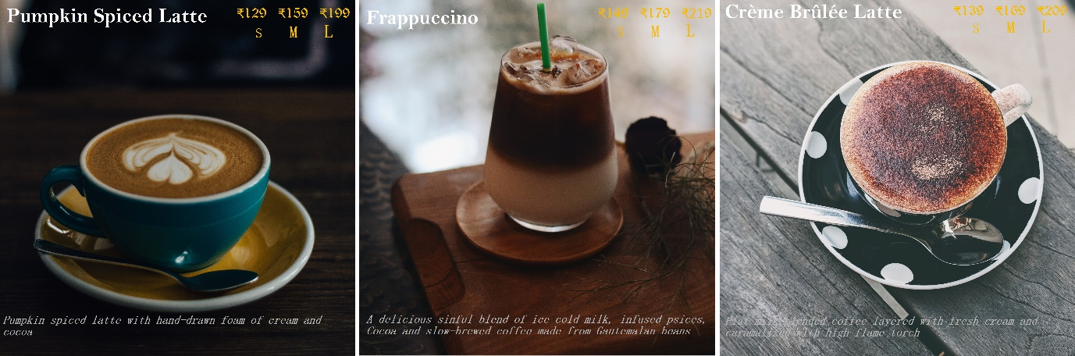

**Cold Coffee**

Cold Brew Coffee €11.99 300 ml (D)

ID: CD-CC-01D

Coffee granules brewed with ice cold water over 24 hours to extract complex flavors 🡪 should appear only when hovered upon

Fruit Fusion Coffee €12.49 300 ml (D)

ID: CD-CC-02D

Cold brewed coffee infused with essence of blueberries and orange prepared over 24 hours

Hazelnut Latte 300 ml €13.49(D)

ID: CD-CC-03D

Cold brewed doppio espresso with whole milk infused with hazelnut and rose extracts

Iced Latte 400 ml €5.49

ID: CD-CC-04

Doppio espresso with foamy milk and ice floats

Café Caramel Chocolate Crunch €8.49 400 ml

ID: CD-CC-05

Chocolate laced coffee served in a glass with a whipped cream mount and topped with caramel ribbons and toasted brazil nut granules

**Hot Coffee**

Kiddoccino €1.69 125 ml (D)

ID: CD-CC-01D

Ethiopian Sidamo medium roasted coffee with whole milk and topped with chocolate sprinkles

Bengaluru Filter Coffee €1.99 200 ml (D)

ID: CD-HC-02D

Filter coffee brewed from medium-roasted Wayanad beans blended with milk froth and cinnamon-spiced sugat

Sumatran Filter Coffee €2.99 400 ml (D)

ID: CD-HC-03D

Filter coffee brewed from home-roasted Sumatran beans. Milk & Sugar Optional

Macchiato €1.49 200 ml

ID: CD-CC-04

Hawaiian Kona Espresso with a small amount of foamed milk

Coffee Cubano €1.69 200 ml

ID: CD-CC-05

Cuban espresso shot brewed from well-roasted beans sweetened with brown sugar

Cappuccino Cubano €2.59 250 ml

D: CD-CC-06

Espresso shot of Coorg Arabica blended with milk and sugar and topped with milk foam

Amaretto Cappucino €8.79 400 ml

ID: CD-CC-07

Double espresso shot of Mexican Altura well-roasted beans infused with foamed milk, amaretto liqueur and topped with caramel

**Sandwich & Wrap**

Cheese Sandwich €4.09 2 slices (D)

ID: CD-SW-01D

Matured cheddar slices with tomatoes and buttered bread

Egg-mayo Sandwich €4.19 2 slices (D)

ID: CD-SW-02D

Egg mayo paste, fresh mustard cress

Hummus Wrap €4.39 6-inch (D)

ID: CD-SW-03D

Hummus, baked potato, zucchini and pumpkin slices, ripple-cut beetroot, julienned carrots and cucumber, picked onion

Vegetarian Burrito €4.69 6-inch (D)

ID: CD-SW-04D

Pan-fried beans & brown rice, sliced onions and tomatoes, lettuce, corn, caramelized onions and cheese

Turkey Salami €5.49 6-inch (D)

ID: CD-SW-05D

Honey turkey salami, boiled quinoa, greens, dill and dijon mustard dressing

Chicken Burger €7.59 6-inch (D)

ID: CD-SW-06D

Pan-roasted chicken, gherkin and tomato slices, lettuce, strained yogurt sauce and fries

Smoked Salmon Sandwich €9.99 6-inch (D)

ID: CD-SW-07D

Triple layer of smoked salmon, goat cheese, lemon squeeze, avocado, dill, garlic-butter paste

**Cake & Mousse**

Spekkoek €5.69 200 gm slice (D)

ID: CD-CM-01D

Classic layered Indonesia cake without any toppings

Schwarzwälder Kirschtorte €6.99 200 gm slice (D)

ID: CD-CM-02D

German cake with several alternating layers of sponge, whipped cream and cherries, topped with a generous chocolate shaving

Strawberry Cake €7.09 200 gm slice (D)

ID: CD-CM-03D

Cake with strawberry cream layers and topped with glazed strawberries

New York Cheesecake €7.69 200 gm slice (D)

ID: CD-CM-04D

This cheesecake is extra creamy on the inside and baked to some firmness on the outside

Australian Pavlova Cake €8.69 200 gm slice (D)

ID: CD-CM-05D

Meringue-based dessert with a crisp crust, a soft and light inside, topped with glazed strawberries and kiwifruit

Dobos Torta €9.39 200 gm slice (D)

ID: CD-CM-06D

Hungarian cake with several alternating layers of sponge, chocolate paste and buttercream and topped with ganache or caramel

Rum & Raisin Tiramisu €10.99 200 gm slice

ID: CD-CM-07

Classic layered Italian mousse with rum-soaked raisins and topped with sweetened smoked almond slices

Syrian H’risseh €11.19 200 gm slice (D)

ID: CD-CM-08D

Syrian nutcake made with semolina flour, rose water, sugar syrup and toasted Levantine nuts

**Merchandize**

keepCup €15.69 200 ml capacity, pack of 6 (D)

ID: CD-MS-01D

Reusable, insulated coffee cup made from BPA-free plastic

coffeeArt T-Shirt €7.99 sizes: S, M , L, XL (D)

ID: CD-MS-02D

T-shirts made with original art developed at your very own dayDream Café. Ask for name personalization at no extra cost!

Parfait Jar 19.99 300 ml, pack of 4 (D)

ID: CD-MS-03D

Parfait jars made from shatterproof glass with a classy metallic tinge to make your dessert tower photos look even more awesome on Insta or FB!

1. Next is coupons. See <https://blog.hubspot.com/website/coupon-css>

Coupon display will be similar to menu display with category filters, a text that popups upon hover (and a place to enter phone number for Special Offers coupons). Coupons will be auto generated from backend and sent over WhatsApp over to the person.

Coupon size: 500x500. Photo size: 500x333 where 333 is the height

The filters are: Festive, Bulk Orders, Special Offers

Each coupon will have validity period of format: validity: MMM DD ‘YY, specific days of the week, time of the day

The arrangement of coupons and responsiveness will be identical to that for menu as the coupon cards are same size as menu.

The following text must be mentioned:

Welcome to dayDream Café giving.

We run regular discount campaigns with our delivery partners. Click here. See below direct giveaways from dayDream Café.

Filter by categories: Today’s Deals 

Expiring tomorrow 

Festive 

Bulk Orders 

Special Offers

Note: in the code below, X-XX-XX-XX-########, 1st letter is C for coupon, 2nd & 3rd are for type of coupon e.g. SO for special offers, 4th & 5th are for menu type e.g. CM for Cake & Mousse, 6th & 7th are for the dish name e.g. SK stands for Schwarzwälder Kirschtorte and the last 8 are numbers representing the date in YYYYMMDD format.

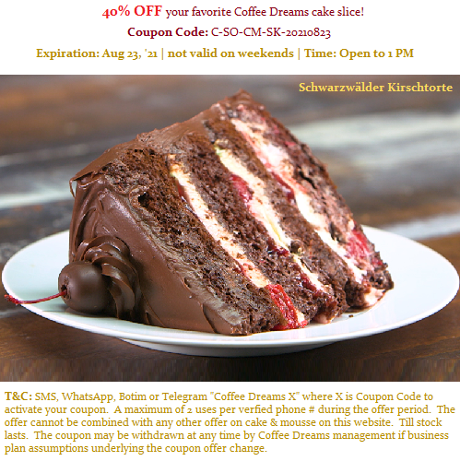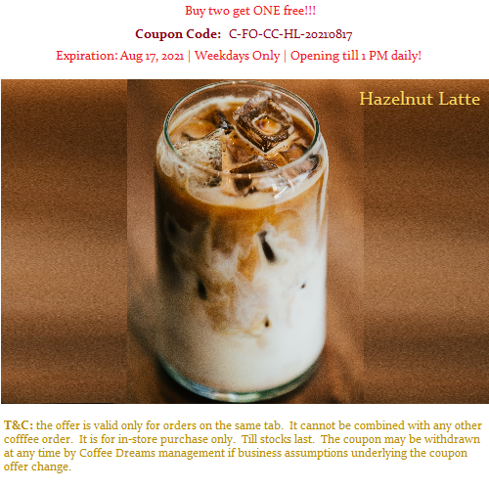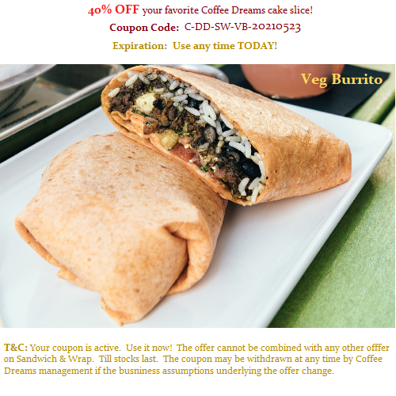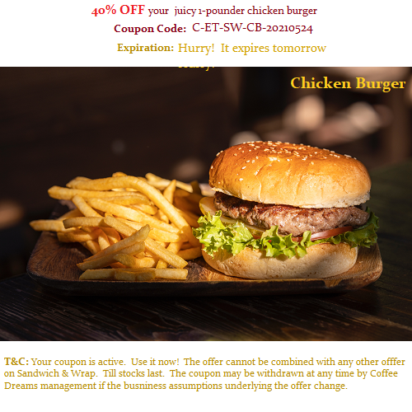

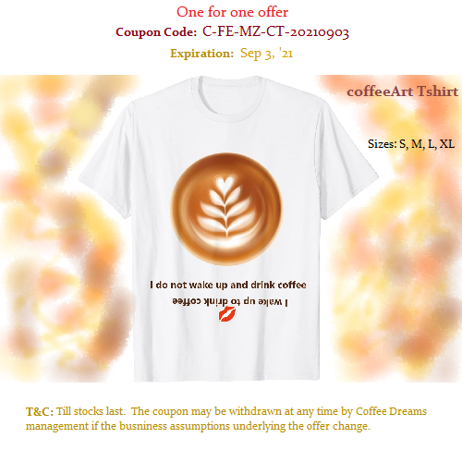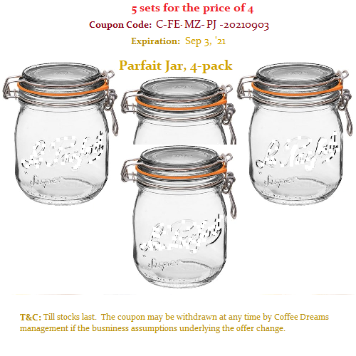

1. Next is Services.

Dine-in 

Reservations 

Catering 

Volunteer

like here <https://desifirangifoods.web.app>

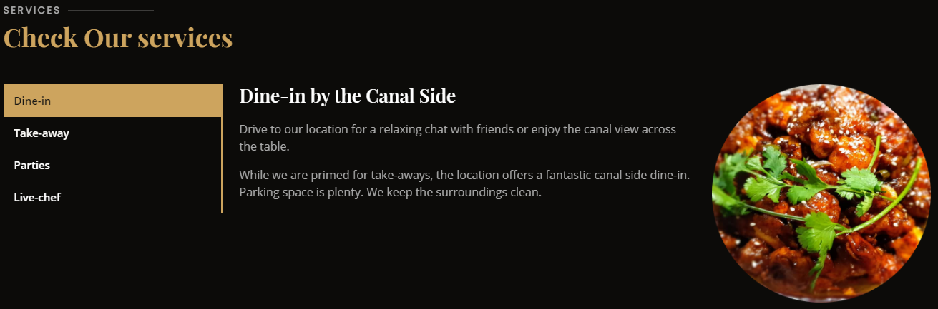

All images are in 1:1 ratio

**Dine-in at dreamDay Café**

You don’t have to get away from the city to *get away from the city*!

Come for long chats with old friends or a casual business meeting. We promise to welcome you right at our door with the fragrance we are famous for.

We open daily. Be sure to drop by for some light live music on the weekends with coffee, cakes and wraps. Br careful though, you never know when you may slide into an addiction!

Use image dineIn01_4424x4424.jpg

**Reservations**

We recommend you reserve if you want to have a good time with many friends or, you want to host an important business meeting in casual surroundings. It also can turn a bit busy during musical weekends.

Call, WhatsApp, Botim or Telegram us. It’s as simple!

Use image Reservations01_2656x2656.jpg

**Catering**

We cater for private parties and themed events. Our baristas and bakery chefs can work up a magic if you call, WhatsApp, Botim or Telegram us.

When you call, be sure to ask about our new crystal, off menu specialties and decorations.

We have been catering since 2018. And our 250+ clients can tell you we are good!

**Volunteer**

You are passionate. You are curious. You are willing to learn. Tasting coffee all day, and dough batters 😊, is your idea of fun. We are looking for YOU!

If you are interested then apply here. We can craft something for you.

Alternatively, if you have computer, drafting, speaking, social media or marketing skills then WhatsApp, Botim or Telegram us for information about how you can join us in our volunteering efforts to make the world a better place.

We turn coffee powder into art and happiness at dayDream Café!

While we are primed for take-aways, the location offers a fantastic canal side dine-in. Parking space is plenty. We keep the surroundings clean.

1. Gallery like here along with FB like icon <http://www.artedelcaffe.com/gallery-en.html> but make the style the same as menu card.

Interior Coffee Art Bread Life Cake Evenings instead of the titles below. FB will automatically send the details to the right of the like button.

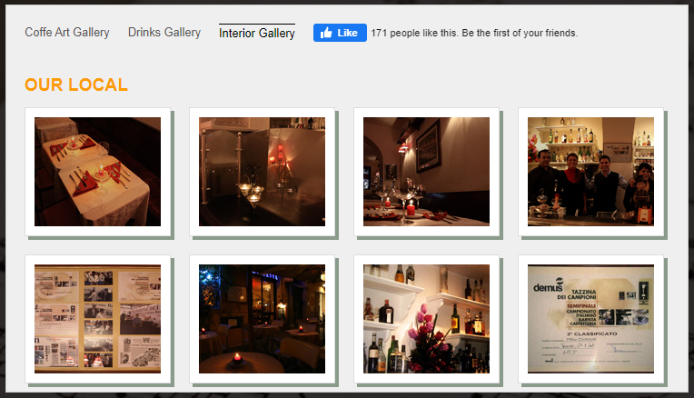

1. Testimonials

I took a client to dayDream as my building was locked out due to a fire drill. The place isn’t as quiet as I was told by a friend but the tables are arranged for privacy and perfect for small meetings. I ordered a light meal of wraps and cold coffees. One deal done. It’s a lovely close-out spot.

Ramnarayan Shresta

Sales Manager, Dubai

The review cards will be like here <https://desifirangifoods.web.app> but card format is given below. The card transition will be the same as in the website.

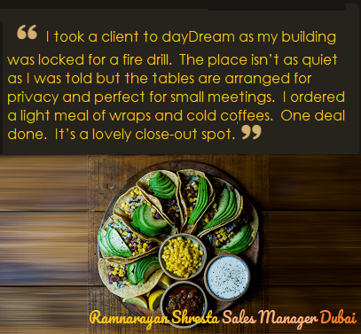

I similarly give below 5 more reviews.

أنا أزور دبي مع أصدقائي. لقد سمعت عن ثقافة القهوة الشهيرة في دبي. أوصلتني توصيات زميل السائح إلى أحلام اليقظة. كنا محظوظين بالوصول عندما كان خبزهم يخرج للتو من الفرن - الخبز الجيد حقًا - يقترب من شوارع دمشق. بيئة عالمية جيدة. فطيرة الجبن نيويورك لذيذة!

حنا زخاري

السياحية، الاسكندرية، مصر

Ils sont à 3 pâtés de maisons de ma maison, donc j'y suis allé assez souvent. Nous les avons engagés pour accueillir le 10e anniversaire de notre fils. C'était cher mais ils ont pris soin de chaque détail et tout le monde a apprécié ses gâteaux, ses sandwichs et son personnel multilingue enthousiaste.

Amélie Prévot

Fleuriste, Dubaï

Ik heb hun taarten geproefd op het promotiefeest van mijn baas. Sindsdien ben ik een vaste klant bij dayDream. Het is een fijne plek om te ontspannen. Ik hou echt van hun Pavlova. Maar Spekkoek met Bengaluru Filter Coffee is gewoonweg hemels.

Frans Van den Bergh

Controle-ingenieur, Sharjah

È difficile per noi apprezzare il caffè perché semplicemente facciamo il meglio! Ci sono stato poche volte. Prova i loro involucri siriani H’risseh o Hummus se hai bisogno di sbrigarti. Altrimenti, Fruit Fusion con Spekkoek si sposa bene con le chiacchierate serali con gli amici.

Constantino Ercolano

Organizzatore di eventi, Dubai

Ich war schon einige Male im DDC. Dies ist ein gemütlicher Ort, an dem man ruhig entspannen und ein leichtes Frühstück am Morgen genießen kann.

Edelmar Ulrich

Künstlerischer Leiter, Fujairah

I volunteered at dayDream Café once. That is how I sampled their entire menu (yepp, almost all of them!). They take pride in what they bake or brew and they do it well. I wish they had some deals for students. It is an expensive place for students though. So do not get addicted!

Dmitri Chernyshevsky

Student, Dubai

1. Contact like here

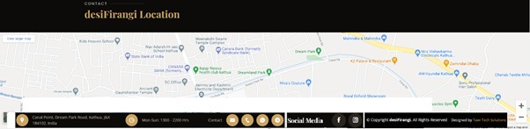

Office Park Building - Abdullah Omran Taryam St - Al SufouhAl Sufouh 2 - Dubai - United Arab Emirates

[+971 4 454 1099](https://www.google.com/search?q=dubai+coffee&safe=active&rlz=1C1CHBF_enIN918IN919&tbm=lcl&sxsrf=ALeKk03vBbfmByFNSrSjZYB9vtno7w791g%3A1619161132931&ei=LHCCYO6UONSDmgets6GQDQ&oq=dubai+coffee&gs_l=psy-ab.3..0l3j0i457k1j0l6.16150.17256.0.17363.6.3.0.3.3.0.138.387.0j3.3.0....0...1c.1.64.psy-ab..0.6.394...0i67k1j0i433i131k1j0i263i20k1j0i433i131i457k1j0i433k1.0.VMtB0ffUpzw) [talabat@dayDreamCafe.com](mailto:talabat@dayDreamCafe.com)

**PHONE VERSION**